
An-Najah National University

Faculty of Engineering

Department of Civil Engineering

Transportation Systems Engineering II - CE 460

Traffic Engineering Laboratory and Project
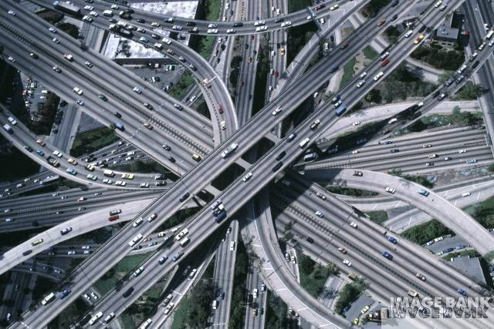
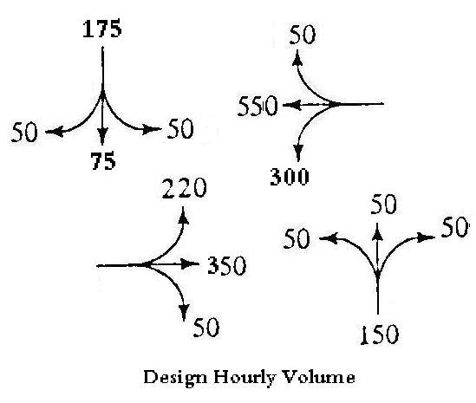

Prepared by:
Dr. Khaled Al-Sahili
Prof. Sameer Abu-Eisheh

Instructors:
Prof. Sameer Abu-Eisheh
Dr. Khaled Al-Sahili
Eng. Hussain Abu Zant
Eng. Mohammad Abu Nimeh
Eng. Khalil Adham

Spring 2010
An-Najah National University - Department of Civil Engineering

Transportation Engineering II - CE 460

Traffic Engineering Laboratory and Project

Laboratory Notes:
- Each student must submit a laboratory report for each project on due date.
- You will work as groups. However, each student must submit his/her own report.
- Copying others’ reports is absolutely not allowed. It may result in a ZERO grade in the project.
- You must show your calculations clearly in the report.
- Each report must contain a discussion and conclusion section. This section may include discussion of the theory, data analysis, conclusions of the project, observations, and comparison between the experimental values and expected values. Discussion of the sources of error may also be included in the discussion.
- You should read the project before you come to the class with reasonable understanding of the theory and the idea behind the experiment.

Laboratory Experiments and Project

Condition Diagram

Speed Studies - Spot Speed Studies (Time-Mean Speed)

Speed Studies – Space-Mean Speed

Traffic Volume - Vehicle Classification Studies - Manual

Traffic Volume - Classification Studies Using Machines

Traffic Volume Studies – Intersections Manually

Traffic Volume Studies – Intersections Using Machines

Parking Study

Pedestrian Volume Count Study

Intersection Delay Study
- Inventory Study
- Intersection Design and Control Project

Grading System:

The laboratory will account for 20% of the total grade for the transportation systems engineering II course

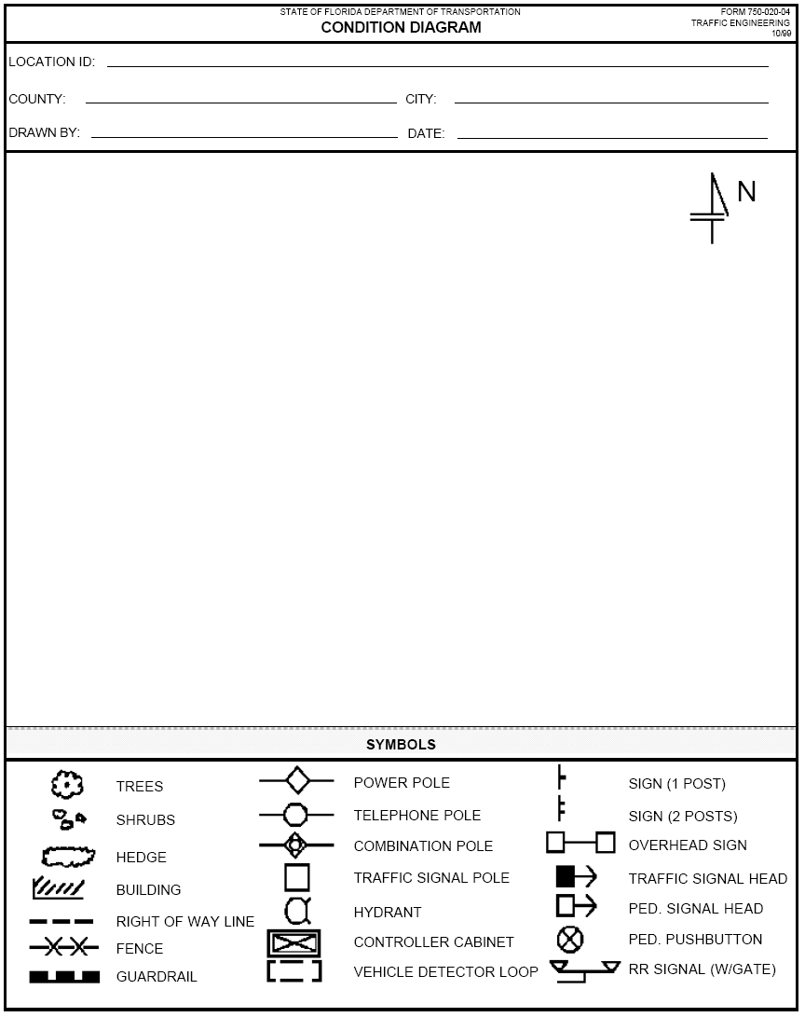
An-Najah National University Department of Civil Engineering
Traffic Engineering Lab.

Project No. 1: Speed Studies

Using Laser Speed Detection Instrument

Background:
Speed studies had been performed through manual methods to measure time vs. measured distance. Later traffic data collectors were utilized to measure speed through computing the time required to cross pneumatic tubes for specified distance. Recently, advanced speed detection instruments have been developed and used to measure speed of vehicles. These instruments have used either microwave radar or laser light beams. The attached part of the operations manual highlights the operation of the use of Laser Speed Detection Instrument which has been recently purchased for our lab.

Field Study:
A location close to the university is to be chosen. A sample of one hundred observations is to be considered.

Required:
- Write a report including purpose, methodology, data collection, analysis, discussion, and conclusions.
- Tabulate the data & find the average speed, standard deviation, & median.
- Draw the speed histogram, the frequency distribution, and the cumulative speed distribution curve.
- Find the range where data lies with confidence levels of 95%, 98%.
- Find standard error of the mean.
- Determine the upper and lower speed limits.
- Determine the 10 kph pace.
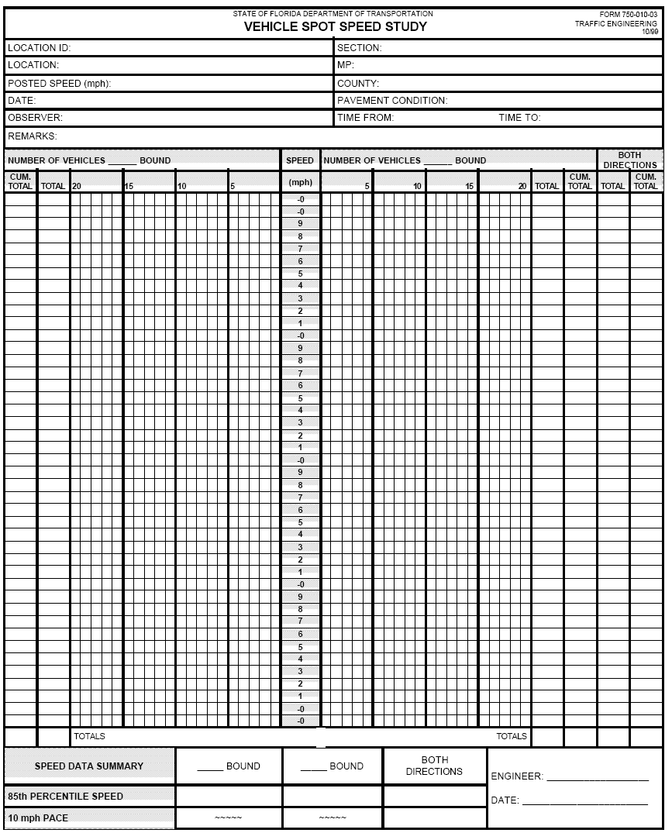
An-Najah National University Department of Civil Engineering
Traffic Engineering Lab.

Project No. 2: Speed Studies

Space Mean Speed

Background:
Speed studies had been performed through manual methods to measure time vs. measured distance. These involve measuring the time required for a vehicle to transverse a measured course. There are a number of devices that can be used to measure time. One of the manual means involve using a stopwatch to measure time. The measured course is specified at the location under study, where two observers cooperate to record time, one at each end of the course. One of the observers starts the watch when the vehicle passes and stops it upon receiving an indication from the other observer that the vehicle passes the end of the course. The length of the course may range from 25m to 75m, where the length depends on the average speed and the location under study (shorter lengths at low speeds and CBD sections and longer lengths at higher speed sections).

Field Study:
A location close to the university is to be chosen. A sample size is to be designed considering a confidence level of 95%, an acceptable error of 1 km/hr, and a sigma of 4.5 km/hr.

Required:
- Write a report including purpose, methodology, data collection, analysis, discussion, and conclusions.
- Design the sample.
- Tabulate the data & find the average speed, standard deviation, and median.
- Draw the speed histogram, the frequency distribution, and the cumulative speed distribution curve.
- Find the range where data lies with confidence levels of 95%, 98%.
- Find standard error of the mean.
- Determine the upper and lower speed limits.
- Determine the 10 kph pace.
- Is there a relationship between space-mean speed and time-mean speed? If yes, what is this relationship?
An-Najah National University Department of Civil Engineering
Traffic Engineering Lab.

Project No. 3: Traffic Volume Studies – Manual

Background:
Congestion problems in Nablus City require an immediate and intensive study of several locations and intersections. A comprehensive study should be conducted to develop a system by which the network should be designed. Due to limited time and resources, spot studies are suggested for this project.

Field Study:
Several counts are to be conducted on different roadways for the purpose of this assignment. The study locations will be given in the lab by the instructor.
Those counts will be limited to volume and classification counts. The counting period will be limited to one-hour due to time limitation. However, an extended-time count will be provided for you based on previous studies.

Required:
- Write a report including purpose, methodology, data collection, data analysis, discussion, and conclusions.
- Tabulate the results for the study.
- Identify the peak hour and peak hour volume for the 10-hr count.
- Estimate the ADT for each street based on your 1-hr count.
- Prepare a traffic flow map.
- Find the peak hour factor for your street.
- Find the percentage of private automobiles, taxis, buses, and trucks at your station.

An-Najah National University Department of Civil Engineering
Traffic Engineering Lab.

Project No. 4: Traffic Volume Studies

Using Electromechanical Data Collection Recorders

Background:
Manual traffic volume counting can be used only for short periods. It requires intensive use of human resources. On the other hand, electromechanical traffic data collectors, which have high initial cost, are used extensively to collect traffic volume counts, especially for longer counting periods. Moreover, many other important variables can be recorded using these equipments, including vehicle classification, speeds, gaps, headways, etc. … To continue investigating problems in Nablus you began in Project No. 1 and 2, more detailed studies are to be performed for a number of stations for volume counts.

Field Study:
A number of study locations will be selected to investigate traffic volumes in Nablus using electromechanical traffic data collectors. Unicorn traffic data collectors are to be used.

Setting Equipment:
Unicorn traffic data collectors have 4 different modes of operation: Raw, Binned, Count, and Sensor. In this project, we are interested in counting and classification. Therefore, we will use the binned mode. This will be reflected on how to use and arrange equipment input road tubes. Each lane is to be sensored by two tubes. Two specialized sensor configurations may be utilized for lane count data, when two road tubes are used, which are lane subtraction and directional (see manual P. 13). Set hardware as described in Section III of the manual. Connect the road tubes according to the plan and you are ready to begin collecting volume data.
After completing data collection, use the interface cable to download the data into the computer using Trafman Software. Get a printed report of your data.

Required:
1. Write a report including purpose, methodology, data collection, data analysis, discussion, and conclusions.
2. Tabulate the results for the study.
3. Identify the peak hour and peak hour volume for your station.
4. Find the peak hour factor for your station.

An-Najah National University Department of Civil Engineering
Traffic Engineering Lab.

Project No. 5: Traffic Volume Studies – Intersection

Manual Counts

Background:
Recent Traffic congesting problems in Nablus, especially along the main arterial crossing the city, attract the attention to study the inbound and outbound traffic volumes as well as the traffic volumes along those arterials, especially at key intersections.

Traffic volumes at intersections can be observed and recorded manually. Special forms can be used for this purpose. The attached form shows the various vehicle classes that might occur on city streets in the West Bank.

Field Study:
As part of the effort, a study of several intersections in Nablus, will be Counted. Manual counting is to be used for turning movements at several locations. Counts should be performed to catch the peak hours.

Location:
Intersections will be illustrated in lab session.

Required:
- Write a report including purpose, methodology, data collection, data analysis, discussion, and conclusions.
- Tabulate the results for the study using the special forms.
- Identify the peak hour and the peak hour volume for your station.
- Prepare an intersection traffic flow diagram.
- Find the peak hour factors for each approach and for the intersection.
- Find the percentage of heavy vehicles at your station.
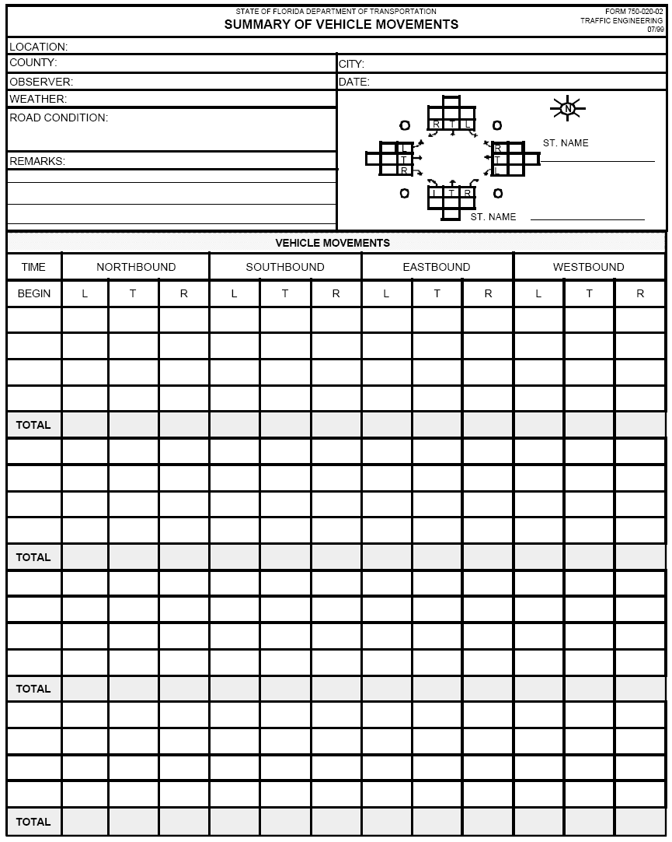
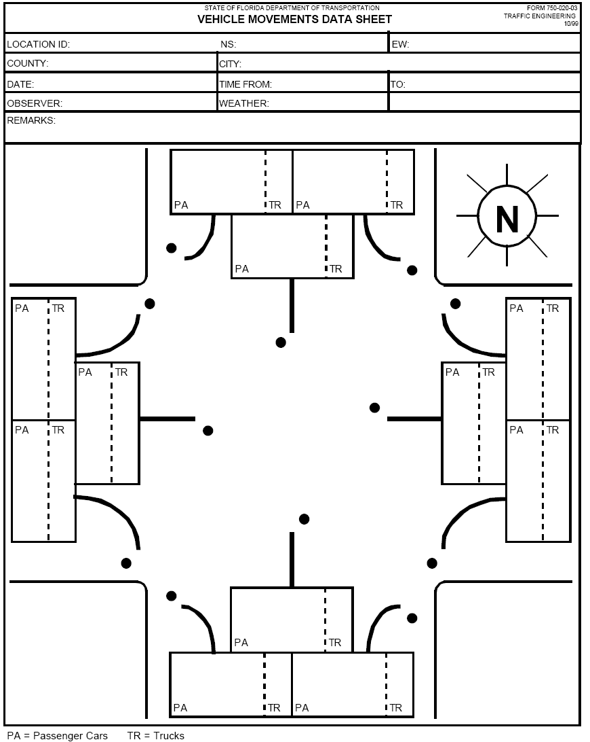
An-Najah National University Department of Civil Engineering
Traffic Engineering Lab.

Project No. 6: Traffic Volume Studies – Intersection

Machine Counts

Background:
Traffic congesting problems in Nablus, especially along the main arterial crossing the city, attract the attention to study the inbound and outbound traffic volumes as well as the traffic volumes along those arterials, especially at key intersections.

Traffic volumes at intersections can be observed and recorded manually or by mechanical hand counters. These machines have been used where pushing buttons manually corresponds to recording vehicles. Recently, and in order to facilitate collection, recording and retrieving of data for short periods of time, electronic data collection recorders have been developed and utilized.

Field Study:
As part of the effort, a study of several intersections in Nablus, will be Counted. Machine counting is to be used for turning movements at several locations. Counts should be performed to catch the peak hours.

Location:
Intersections will be illustrated in lab session.

Required:
- Write a report including purpose, methodology, data collection, data analysis, discussion, and conclusions.
- Tabulate the results for the study using the special forms.
- Identify the peak hour and the peak hour volume for your station.
- Prepare an intersection traffic flow diagram.
- Find the peak hour factors for each approach and for the intersection.
- Find the percentage of heavy vehicles at your station.
An-Najah National University Department of Civil Engineering
Traffic Engineering Lab.

Project No. 7

Parking Study

Background:
Parking problems are clearly noticed in Nablus Central Business Area. The increase in the number of vehicles and their usage and consequently in the demand for parking has not been accompanied with parallel increase in the supply of parking spaces, or in planning and implementing time restrictions and other parking controls. To determine the extent of and severity of the problem, it is necessary to determine the existing parking supply and current usage.

Field Study:
Each team will be assigned a section of Nablus CBD to survey. Locations will be specified in the lab.

Required:
Write a report including purpose, data collection, calculations, analysis, discussions, and conclusions. In the report, give answers for the following:
1. Indicate the results of parking inventory study for your location.
2. Find the supply and practical capacity.
3. Find parking accumulations and present it graphically.
4. Find the utilization rate. Comment!!
5. Describe the parking duration observed. Comment!!
6. Does the problem of double parking exist?
What about the percent of violating vehicles?
7. Are current parking conditions sufficient?
Make recommendations for improvements.
CE 460 - Traffic Engineering
Parking Studies
An-Najah National University |  |  |  |  |  | Department of Civil Engineering
Traffic Engineering
City:_______________________ |  |  | Date:____________________ |  |  | Location: __________________________
Street:____________________________________ |  |  | Between__________ |  | and:_________________
Number of Spaces:________________________
Time Beginning | Facility No. | Parking Type | Parking Accumulation | Time Beginning | Facility No. | Parking Type | Parking Accumulation
8:00 |  |  |  | 12:00
8:15 |  |  |  | 12:15
8:30 |  |  |  | 12:30
8:45 |  |  |  | 12:45
9:00 |  |  |  | 13:00
9:15 |  |  |  | 13:15
9:30 |  |  |  | 13:30
9:45 |  |  |  | 13:45
10:00 |  |  |  | 14:00
10:15 |  |  |  | 14:15
10:30 |  |  |  | 14:30
10:45 |  |  |  | 14:45
11:00 |  |  |  | 15:00
11:15 |  |  |  | 15:15
11:30 |  |  |  | 15:30
11:45 |  |  |  | 15:45

An-Najah National University Department of Civil Engineering
Traffic Engineering Lab.

Project No. 8: Pedestrian Volume Count Study
Background:
Pedestrian traffic volume is relatively heavy in major downtowns in Palestinian cities. Pedestrians cross streets from any location whether it’s a designated pedestrian cross-walk or not. These random and unorganized pedestrian crossings cause major vehicular delays at heavy pedestrian areas. The study of pedestrian volume assists in evaluating the vehicle/pedestrians interaction. This study is also used to examine “Warrant: Minimum Pedestrian Volume.”
Field Study:
Each group is required to perform a pedestrian volume count study at various intersections/streets in the City of Nablus. The study should be performed in 15- minute intervals during the peak period for one hour. The number of pedestrian volumes (and sometimes vehicular volume) should be counted. Two different study forms are to be completed in this study: “Pedestrian Volume Sheet” and the “Summary of Pedestrian Movements.”
Location:
Study locations will be provided during the laboratory session.
Required:
Write a report including: purpose, data analysis, discussion, and conclusions. In the report, you should also:
- Fill out the appropriate forms, draw a sketch, and tabulate the results.
- Determine the peak hour and peak hour pedestrian traffic volume.
- Does the problem of pedestrians crossing from undesignated areas exist? If yes, discuss the impact on pedestrian safety and vehicular traffic operation.
- Does the age group of pedestrians and their associated walking speed vary significantly? What is the estimated average walking speed?
- What is the predominant pedestrian age group?
6. Discuss the impact of pedestrian volume and their age group on traffic signal design and operation.
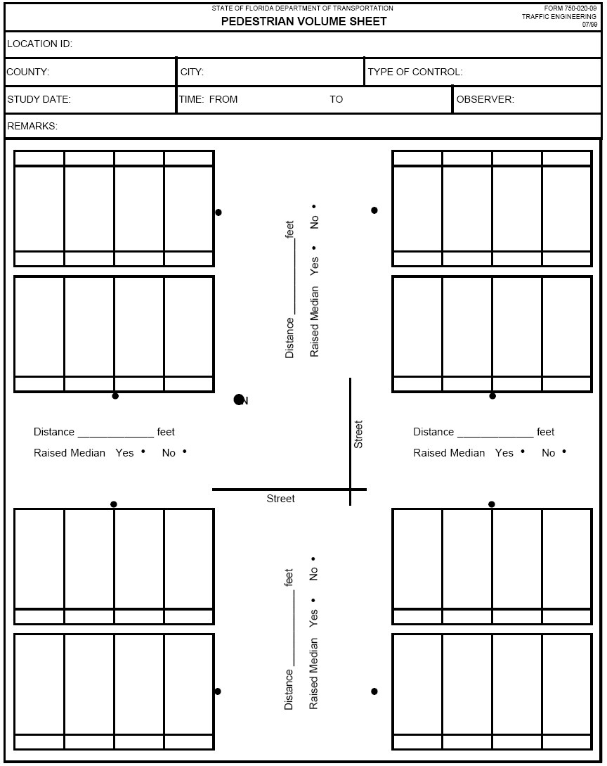
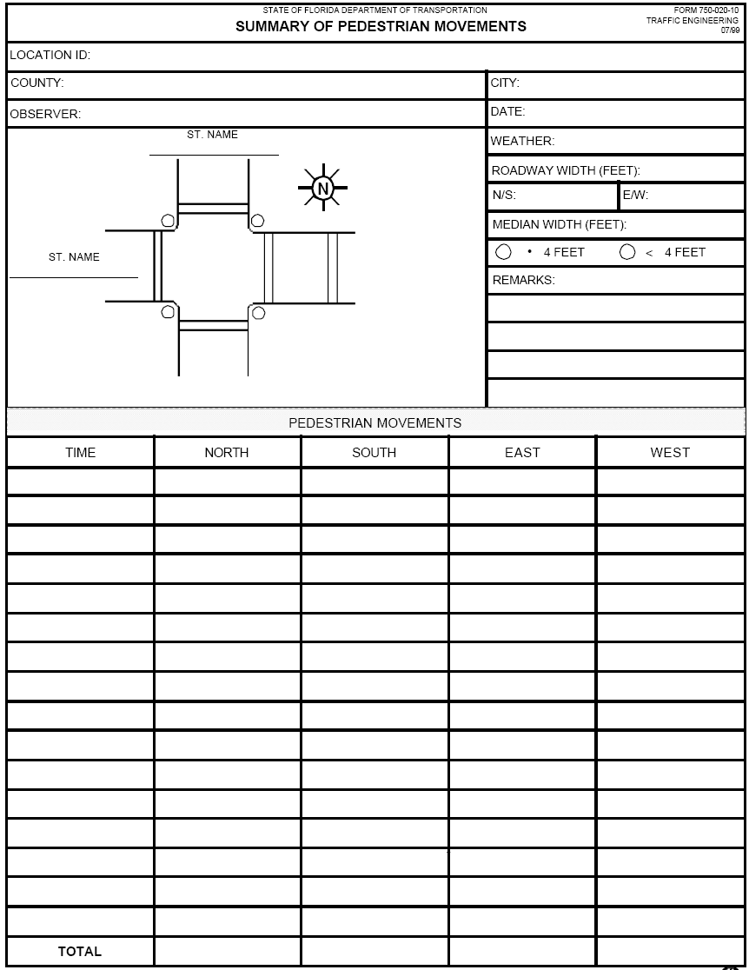
An-Najah National University Department of Civil Engineering
Traffic Engineering Lab.

Project No. 9: Intersection Delay Study

Background:
Delay is observed at a number of intersections in the area of Nablus and other Palestinian cities. The study of delay at intersections would assist in evaluating the performance of those intersections.

Field Study:
Each group is required to perform an intersection delay study at the same intersections where the intersection traffic count was performed. The study should be performed with 15 sec. observation intervals for the period extending 15 minute during the peak period. The number of stopped vehicles by the end of each interval is to be counted. In addition, total discharge volume (including stopping or non-stopping vehicles) at the Yield or Stop sign controlled approach should be counted.

Location:
Study Intersections will be provided during the laboratory session.

Required:
Write a report including: purpose, data analysis, discussion, and conclusions. In the report, you should also:
1. Tabulate the result.
2. Calculate:
- Percent stopping vehicles
- Stopped delay
- Approach delay
- Average stopped delay per vehicle
- Average approach delay per vehicle

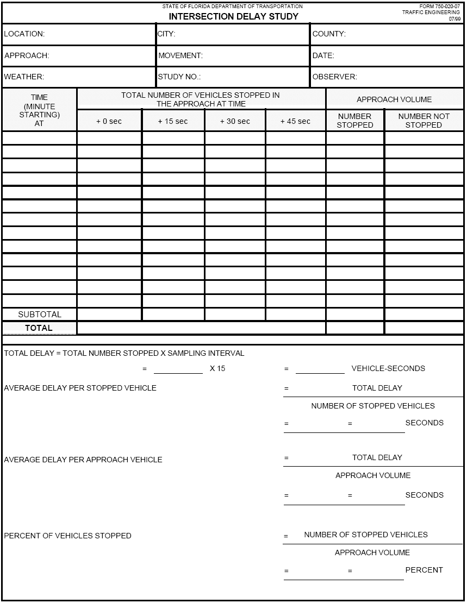
An-Najah National University Department of Civil Engineering
Traffic Engineering Lab.

Project No. 10

Inventory Study

Background:
The general characteristics or roads in Palestinian cities are somewhat the same. Inventory of roads are hardly done in these cities. Road network is not officially classified in a systematic way according to set standards. Road signs are somewhat limited or need maintenance or replacement. Most roadway sections have two lanes; one lane per direction. Pavement conditions are fair to poor except at locations where streets have been recently resurfaced.
The road inventory study is an important task that each jurisdiction should do to identify their assets. These studies include roadway classification and roadway elements. Standard forms are typically used for this purpose.

Field Study:
This study focuses on the inventory of existing conditions along some selected sections/intersections in the vicinity of An-Najah National University. These locations will be identified during lab sessions. One should pay attention to special conditions of traffic and geometry along the study sections. Students may use the attached form to facilitate collecting the information. Additional information may be added as seen necessary by the observer.

Required:
- Write a report including purpose, methodology, data collection, data analysis, discussion, and conclusions.
- Write your observations regarding special features (traffic and geometry) of the study location.

FIELD INVENTORY FORM

DATE
GOVERNORATE CITY LOCATION

Section Type □ mid-block □ intersection
Number Intersection Legs □ 3 □ 4 □ Multi

Pavement Markings □ Good condition □ Poor condition □ Doesn’t exist

Median Opening

Roadway East Approach □ Divided □ undivided □ Yes □ No

West Approach □ Divided □ undivided □ Yes □ No

South Approach □ Divided □ undivided □ Yes □ No

North Approach □ Divided □ undivided □ Yes □ No

Number of Lanes EB ……… Lanes

WB ……… Lanes

SB ……… Lanes
NB ……… Lanes

Horizontal Alignment N-S □ Straight □ Curve

E-W □ Straight □ Curve

Vertical Alignment N-S □ Gradient □ Level

E-W □ Gradient □ Level

Shoulder East Approach □ Yes □ No Width = m
West Approach □ Yes □ No Width = m
South Approach □ Yes □ No Width = m
North Approach □ Yes □ No Width = m

Sidewalk East Approach □ Yes □ No Width = m
West Approach □ Yes □ No Width = m
South Approach □ Yes □ No Width = m
North Approach □ Yes □ No Width = m

Drainage Facilities □ Good □ Poor □ Doesn’t exist
Surface Type □ Asphalt □ Concrete □ Gravel □ Dirt
Roughness □ Rough □ Smooth

Surface Defects □ Rutting □ Potholes □ Corrugation □ Bleeding
□ Raveling □ Nothing □ Others

Traffic Control □ Stop sign □ yield sign □ Traffic signal
□ Policeman □ No control

Parking Control in the Vicinity □ Parking □ No Parking
Loading Facilities in the Vicinity □ Yes □ No

Land Uses □ Commercial □ Residential □ Industrial
□ School zone □ Mixed □ Other

Night Light Condition □ Good □ Fair □ Poor
Speed Limit EB = Km / h
WB = Km / h
SB = Km / h
NB = Km / h

Roadside Feature
Poles □ East Approach □ West Approach
□ South Approach □ North Approach
Rocks □ East Approach □ West Approach
□ South Approach □ North Approach
Side Slopes □ East Approach □ West Approach
□ South Approach □ North Approach
Trees □ East Approach □ West Approach
□ South Approach □ North Approach
Safety Barriers □ East Approach □ West Approach
□ South Approach □ North Approach
Other □ East Approach □ West Approach
□ South Approach □ North Approach

Visibility of Traffic EB □ Good □ Fair □ Poor
Control Devices WB □ Good □ Fair □ Poor
SB □ Good □ Fair □ Poor
NB □ Good □ Fair □ Poor
Sight distance EB □ Good □ Poor
WB □ Good □ Poor
SB □ Good □ Poor
NB □ Good □ Poor
An-Najah National University Department of Civil Engineering
Traffic Engineering Lab.

Project No. 11

Intersection Analysis and Control

Background:
It has been noticed that traffic congestion in Nablus, and in other urban areas in the West Bank, are most severe at key intersections. Proper intersection design and control is very important in assigning right of way, improving traffic flow through the intersection, and enhancing safety.
Intersection design features include number of lanes, lane widths, proper channelization, curb radii, etc. Intersection control features include proper installations of traffic control devices including signs and markings. At specific intersections, and if warranted, traffic signals must be installed. To evaluate the performance of an intersection, capacity and level of service analysis are usually performed.

Field Study:
This study focuses on intersection design and control at key intersections.
First: intersection approach geometries have to be identified. Next: an inventory of control measures at the approaches and of existing traffic control devices at the vicinity of the intersection is to be performed. This, in addition to the peak hour traffic volumes at the intersection considered, which you have performed in Lab. Ass. No. 5 or will be supplied, form a basis for proper design and control.

Required:
- Write a report including purpose, methodology, data collection, data analysis, discussion, and conclusions.
- Draw the intersection at a proper scale showing all existing geometric and control features including traffic control devices.
- Analyze the appropriateness of the current geometric and traffic control devices.
- Suggest modifications and make proper geometric design for the intersection including channelization and draw using a proper scale.
- Suggest modifications to traffic control and show suggested traffic control devices for the intersection.
- Check whether a traffic signal is warranted.
- If a traffic signal is to be installed. Design the signalization plan, showing phases, cycle length, intervals, split, etc.

